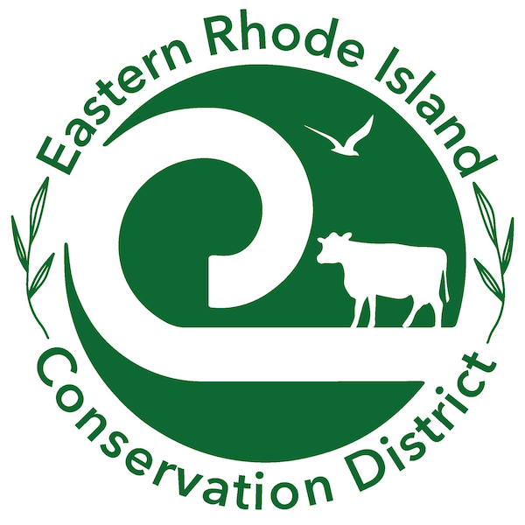
2026 Community Wish List

Portsmouth AgInnovation Farm (ERICD)
Mission: | ERICD’s vision is to foster a healthy and resilient environment by advancing the conservation of natural habitats and natural resources such as soil, water, and air for the well-being of future generations. Our mission is that through community outreach and partnerships with farmers, residents, and municipalities, we enhance natural resources and strengthen the environmental resilience of Newport and Bristol counties.
Donations
Website and Link to Donate: | https://www.easternriconservation.org/
Mailing Address for checks: | PO Box 158 | Tiverton, RI 02878
In-Kind Donation Requests
Address for Drop Off: | Farm is across the street from 437 Jepson Lane, Portsmouth
Days of Week Accepted: | Call 401-934-0842 to schedule an appointment for drop off
Times of Day Accepted: | . Call 401-934-0842 to schedule an appointment for drop off
Drop off Instructions/ Limitations/Notes: | Call 401-934-0842 to schedule an appointment for drop off
Organization Contact for In-Kind Donation Questions: | Name: Sara Churgin  Email: sara@easternriconservation.org  Phone: 4 0 1 - 934 - 0842
Donations Requests:  Links to requested products | - Compost to help amend the soil  - Weedwacker  - Broadfork to aid with planting  - Hotbox to insure water in the winter  - Jang seeder, to aid planting seeds over a large area.  - Stirrup hoe for weeding  - Digital scale to weigh produce  - Round trip tote for donating produce  - Gas cards for farm equipment  - Hay  - Seed Trays
Volunteer Opportunities
Volunteer Coordinator: | Name: Margie Brennan  Email mailto:margiebrennan44@gmail.com
Volunteer Opportunities: | Help with weeding, harvesting, planting, etc.  Help with project installation at AgInnovation Farm (e.g., building a fence)  Prepping community gardens in the spring and winterizing gardens in the fall.  .

